

Deep Linking Technical Document v1.1

Contents

1. Configure Branch.io Dashboard 2

2. Configure Your Mobile App (Native Android) 2

a. Enter app information 2

b. Get the SDK files 3

c. Configure Manifest 3

d. Start a Branch session: 4

# Configure Branch.io Dashboard

We started by creating a New Branch.io App that connects with the Mobile Application. Once the app is created, a Branch Key and a Branch Secret are generated. Those values are used to authenticate between Branch.io App and the Mobile App, and can be viewed on the Dashboard under Account Settings.

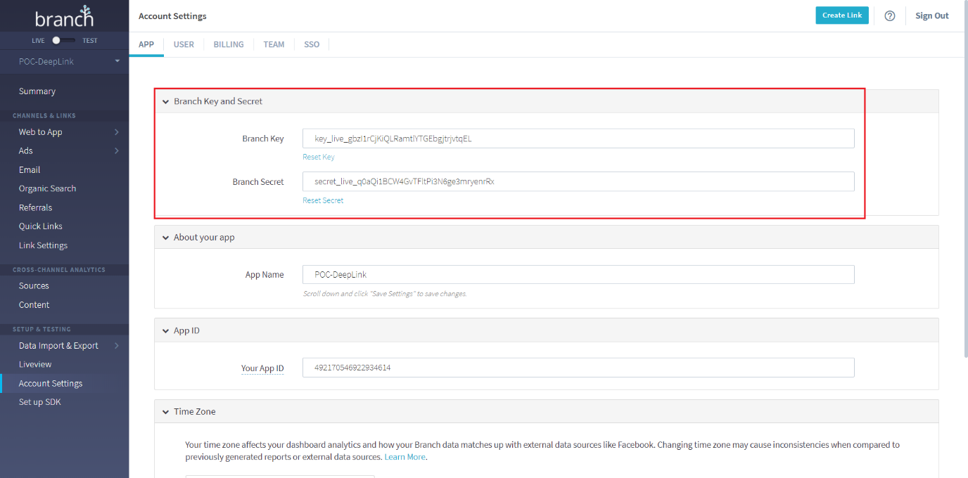

For further details, refer to the following documentation: <https://docs.branch.io/pages/dashboard/integrate/>

# Configure Your Mobile App (Native Android)

Under ‘Set up SDK’ on the left-side menu, we followed the tutorial provided by Branch.io.

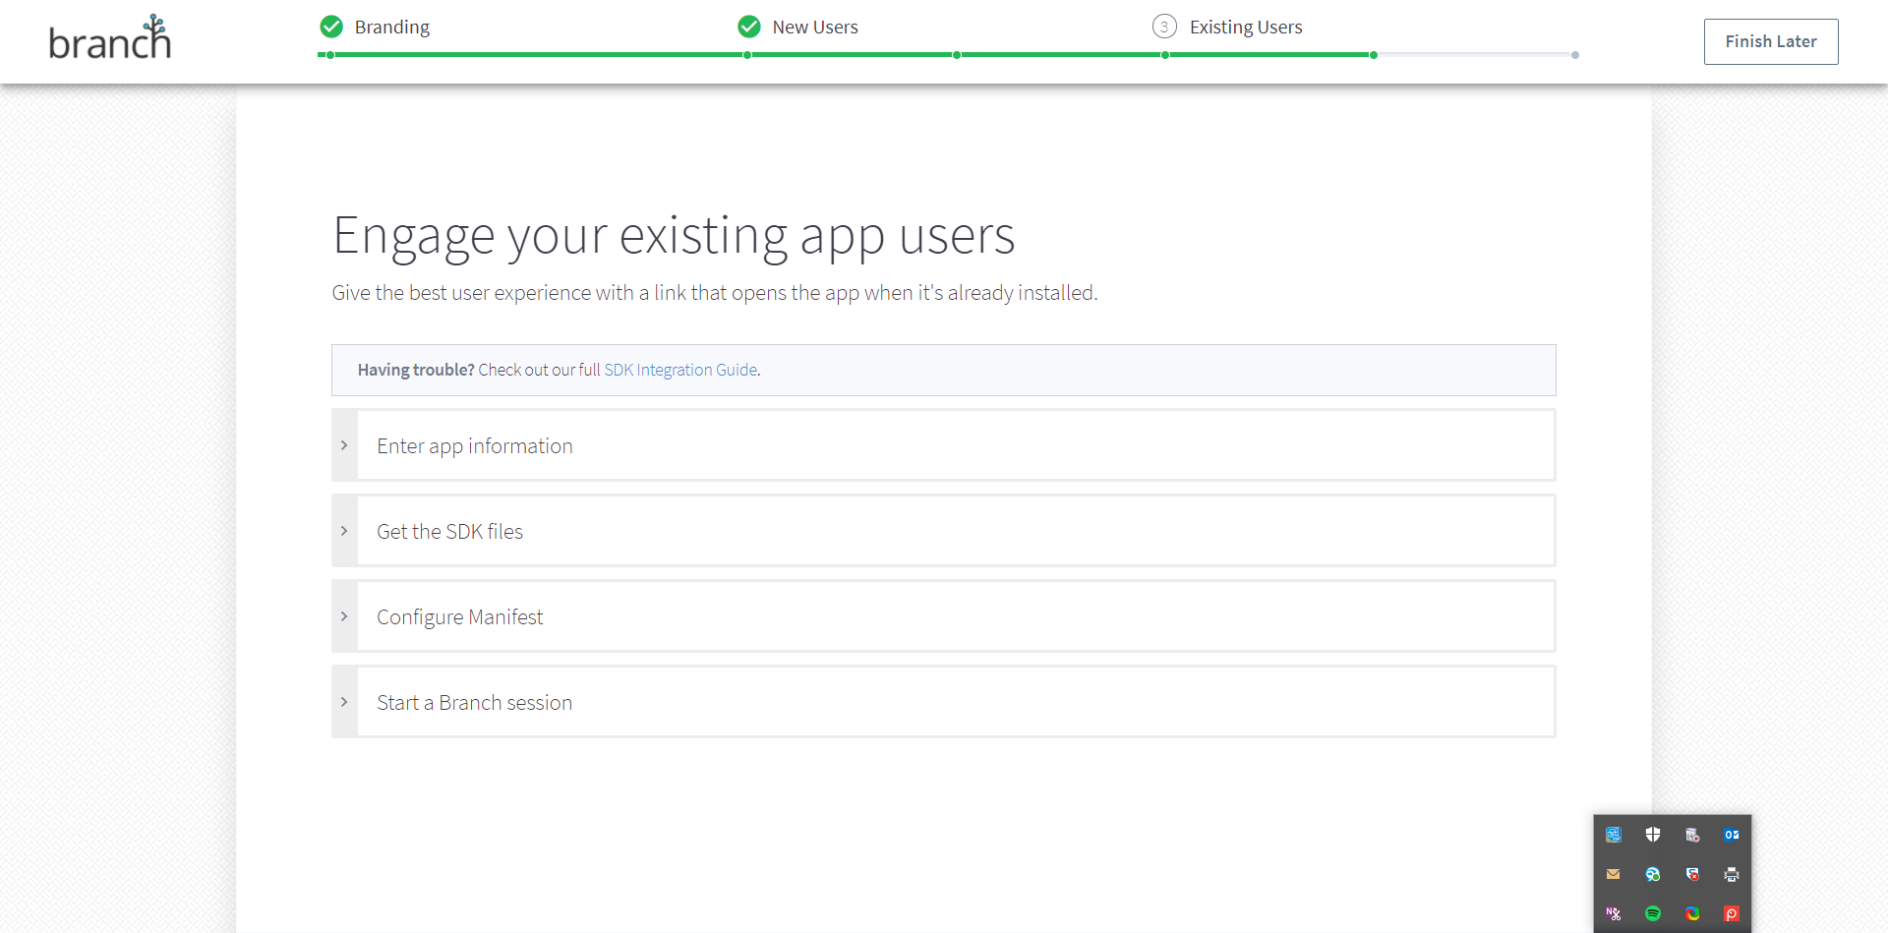

## Enter app information

* In the first field, we entered the location of the Android installation package.
* We checked Enable App Links.
* In the URI scheme filed, we entered the Mobile App name with the format yourapp://

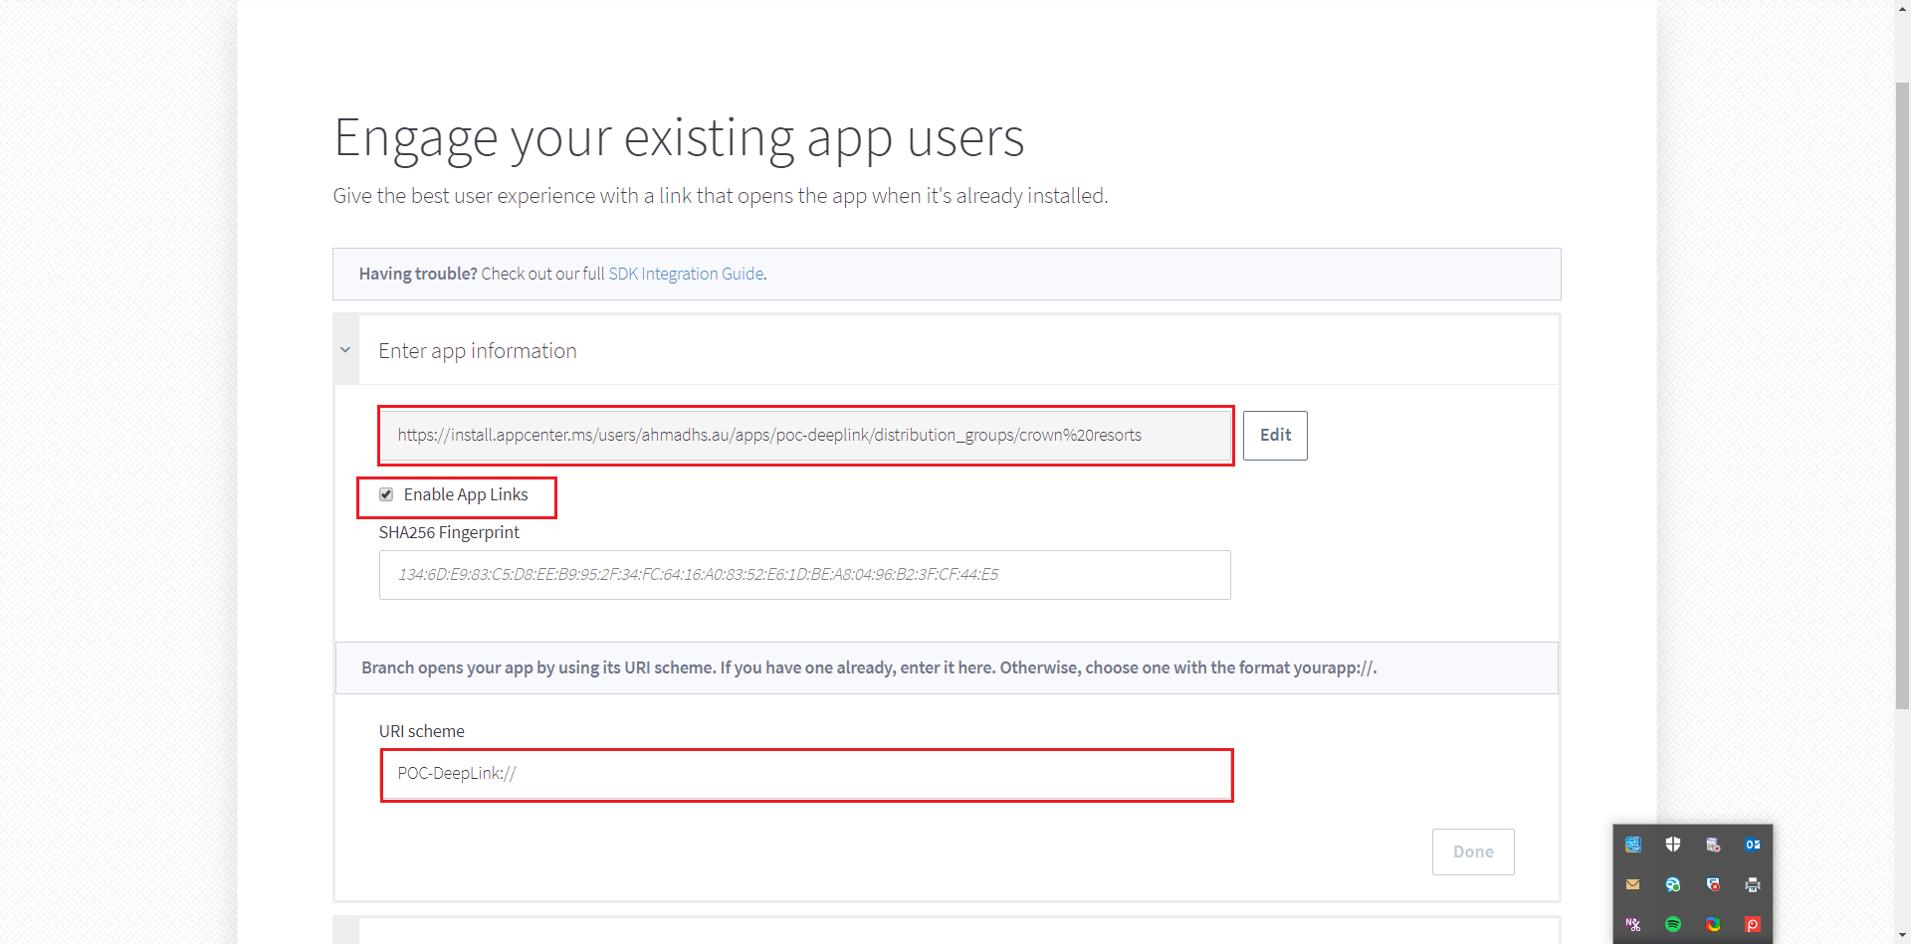

## Get the SDK files

We added the following to the build.gradle of the Mobile App:

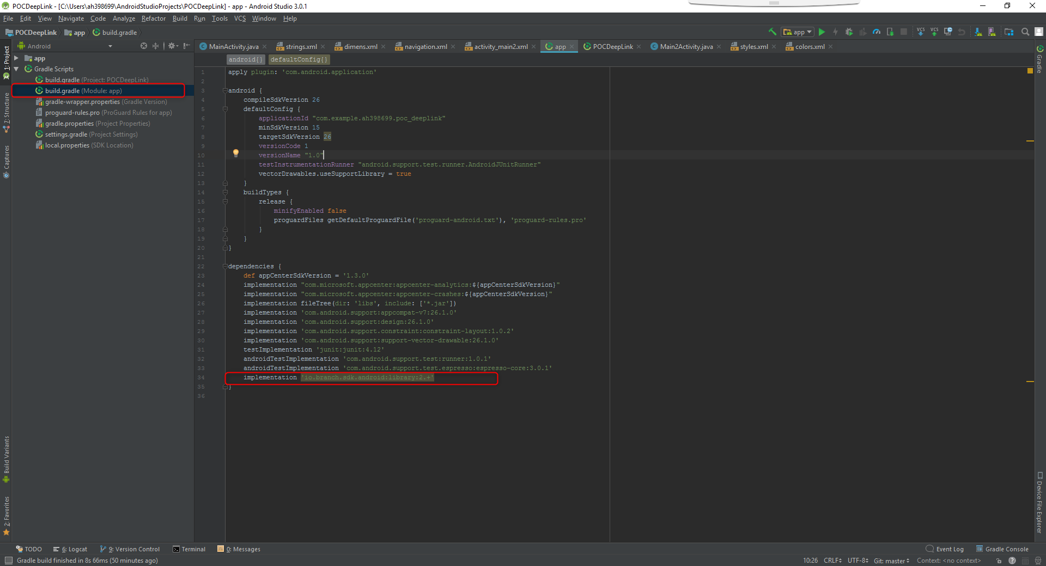

## Configure Manifest

In the AndroidManifest.xml file, we added the following:

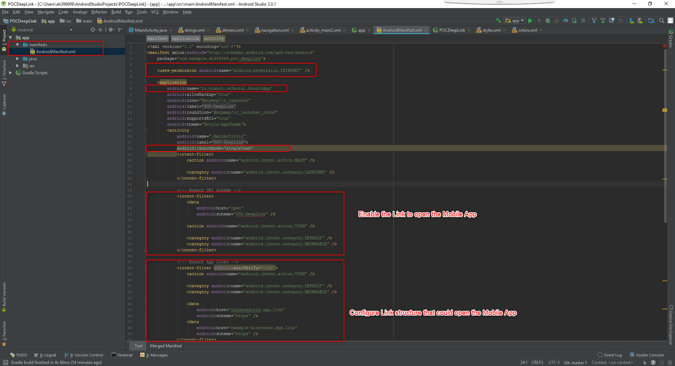

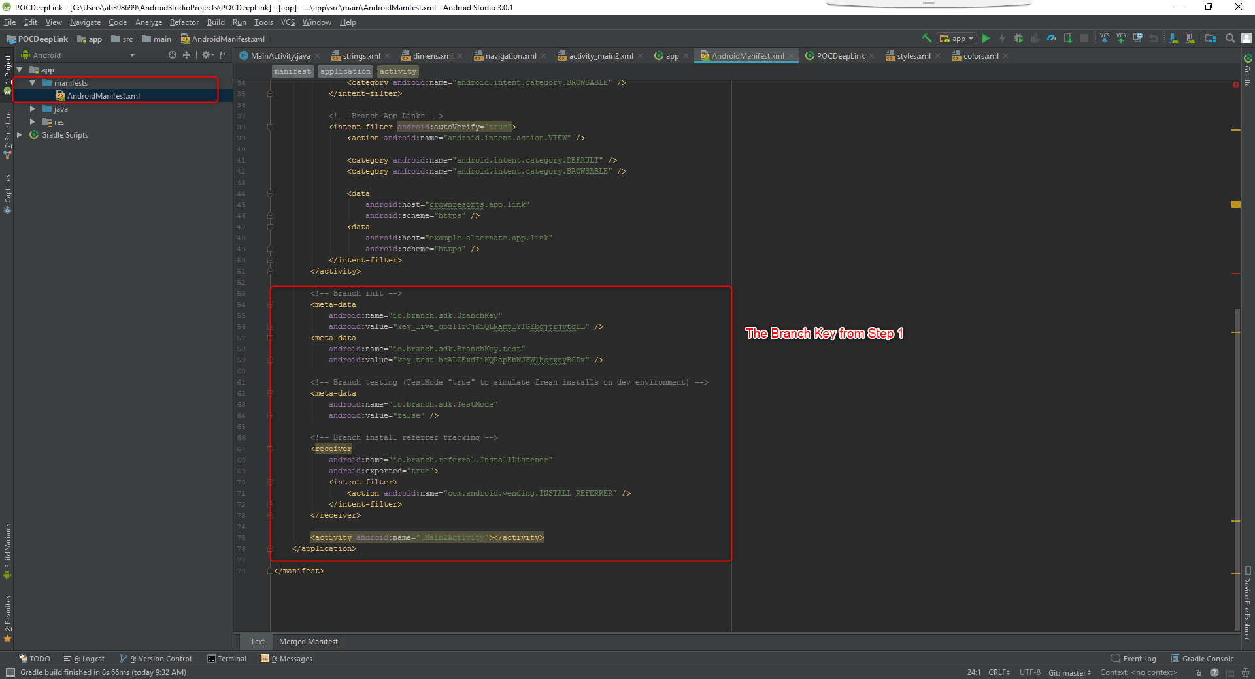

## Start a Branch session:

We Added the following to the MainActivity file of our Demo App Project:

